1. This project was about creating a program to make and sort items in a grocery store into categories by human input. The program involves typing a category and an item and entering the data into the dictionary. There is a button to show the categories and you can click on the category to show what items are in it.
2. I did not keep daily/change logs. I did the basic structure of the code last Tuesday, the GUI work last Thursday, and finished the unit testing earlier today.
3. The project core concept stayed the same, but the idea of doing it in Python and the idea to create a button to show the items in a category were different from when I first imagined the project. The main problem I had was remembering how to do GUIs in Python and looking up how to do a list box, since the last time I used Python was last semester and I never did a list box back then. It did not take long to relearn how to do GUIs and GeeksForGeeks is always helpful in learning about coding.
4. [jab1122/Data-Structure-Final](https://github.com/jab1122/Data-Structure-Final)
5. Step 1: create a category and an item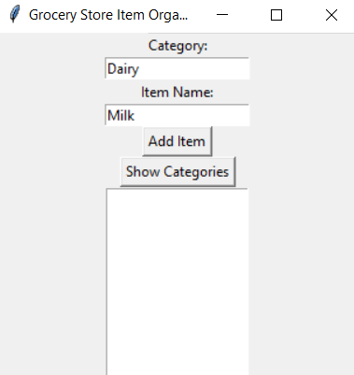
   1. Step 2: enter them in with the Add Item button

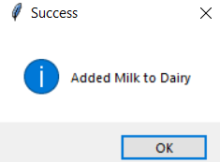

* 1. Step 3: repeat first 2 steps as long as needed
  2. Step 4: click the Show Categories button

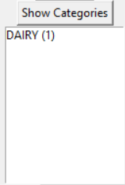

* 1. Step 5: click on a category to see the items in it

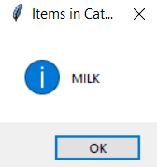

1. The code is efficient and has enough whitespace to be easily readable. The code does exactly what I set out to do. The code is stable as far as I can tell since I have not had it fail yet. The code is short enough to be considered elegant in my opinion. The project was a success in general because it works how I wanted it to work, with a user entering any category and item they want and it being added to the program to be able to be viewed later. Future versions of the program could include bulk of an item and an update button to change the bulk of an item.